1) Choose any website for testing with approval from the mentor

2) Report Bugs

Website - <https://virpp.com/explore>

**ID** - 001

**Environment** - Google Chrome, 102.0.5005.61

**Title** - After clicking many times on the left arrow of the carousel - the arrow, “Play” button and “Like” button are missed

**Severity** - High

**Priority** - High

**Steps to reproduce**

* Go to <https://virpp.com/explore>
* Click on the left arrow on the carousel many times
* Pay attention to the arrow, “Play” button and “Like” button

**Actual result** - When clicking many times on the left arrow of the carousel - the arrow, “Play” button and “Like” button are missed

**Expected result** - When clicking many times on the left arrow of the carousel it has to work as usual

**Attachments**

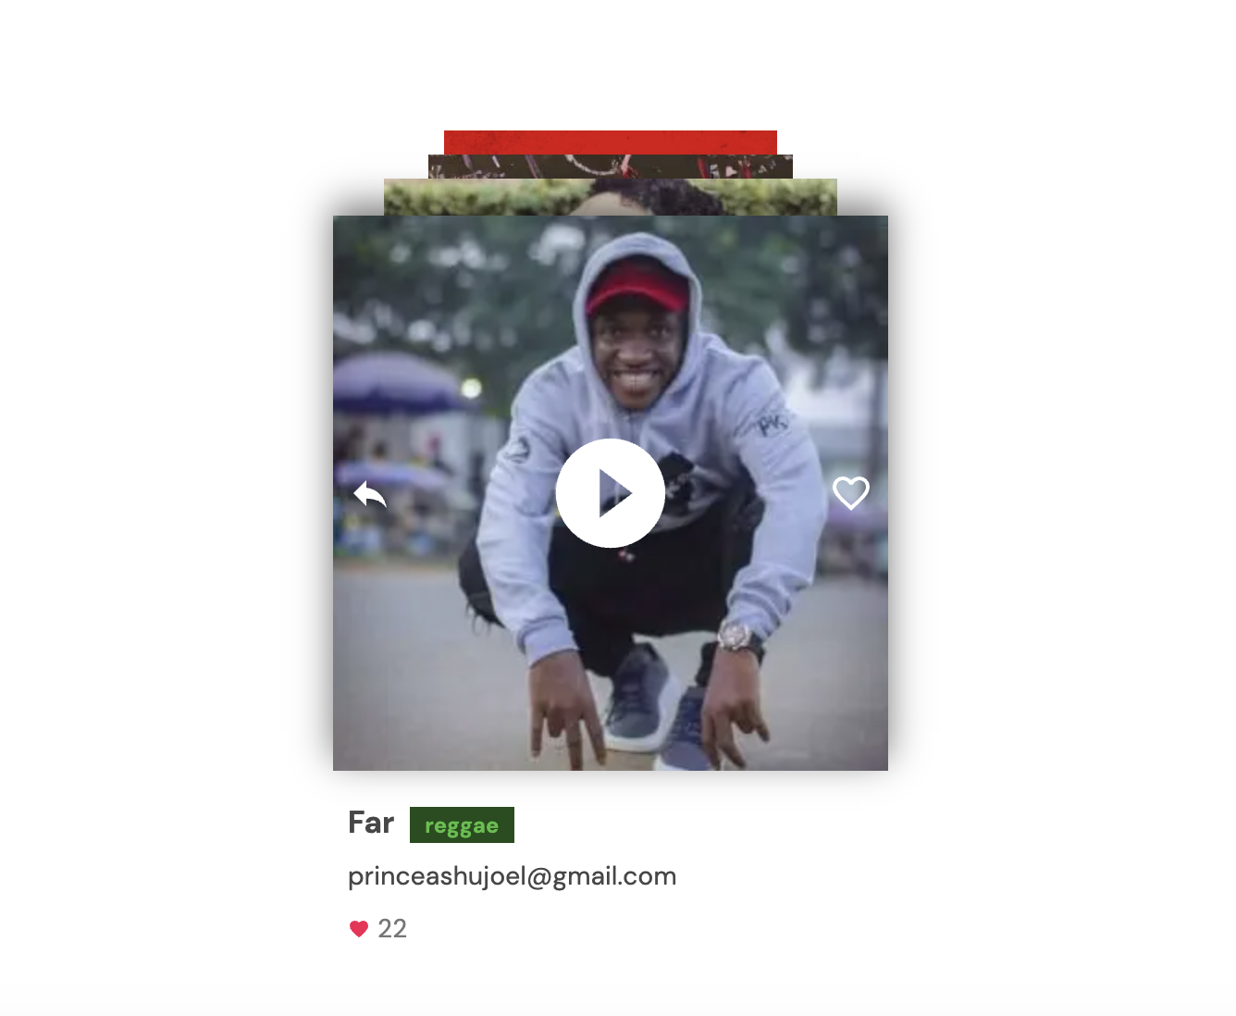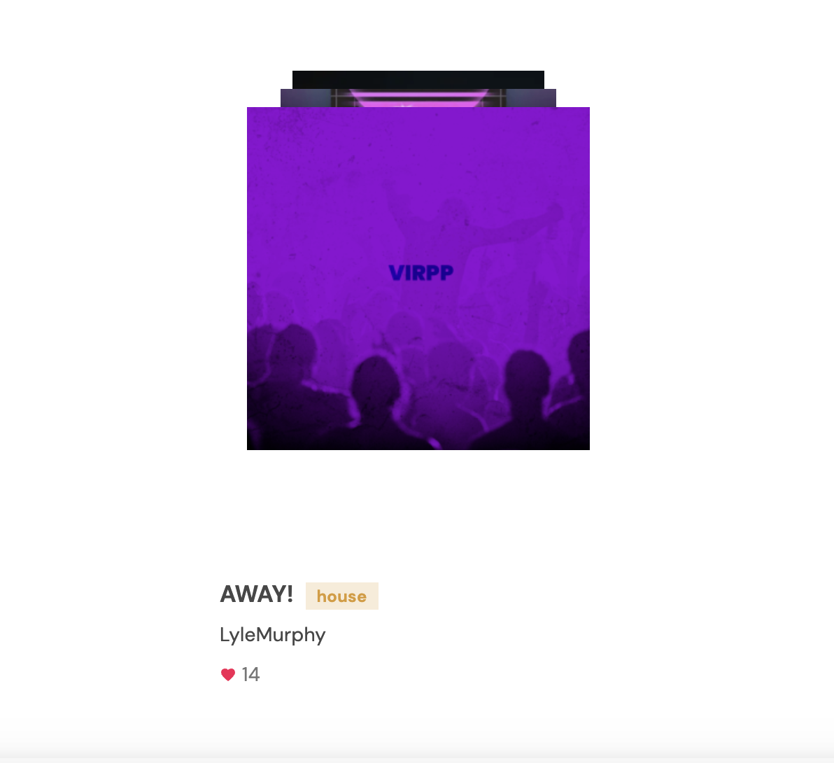

**ID** - 002

**Environment** - Google Chrome, 102.0.5005.61

**Title** - After clicking many times on the left arrow of the carousel - the arrow, “Play” button and “Like” button don’t respond

**Severity** - High

**Priority** - High

**Steps to reproduce**

* Go to <https://virpp.com/explore>
* Log in with the test data (Login - [test@dot.com](mailto:test@dot.com), Password - test123)
* Click on “Explore” on the main menu
* Click on the left arrow on the carousel many times
* Pay attention to the arrow, “Play” button and “Like” button

**Actual result** - When clicking many times on the left arrow of the carousel - the arrow, “Play” button and “Like” button - don’t respond

**Expected result** - When clicking many times on the left arrow of the carousel it has to work as usual

**ID** - 003

**Environment** - Google Chrome, 102.0.5005.61

**Title** - After clicking many times on the arrow of the carousel, different labels on the carousel and footer player are showed for some time

**Severity** - High

**Priority** - High

**Steps to reproduce**

* Go to <https://virpp.com/explore>
* Log in with the test data (Login - [test@dot.com](mailto:test@dot.com), Password - test123)
* Click on “Explore” on the main menu
* Click on the left arrow on the carousel much time
* Pay attention to the carouser and footer player

**Actual result** - after clicking many times on the arrow of the carousel , different labels on the carousel and footer player are showed for some time

**Expected result** - it has to be shown the same labels on the carousel and footer player

**Attachments**

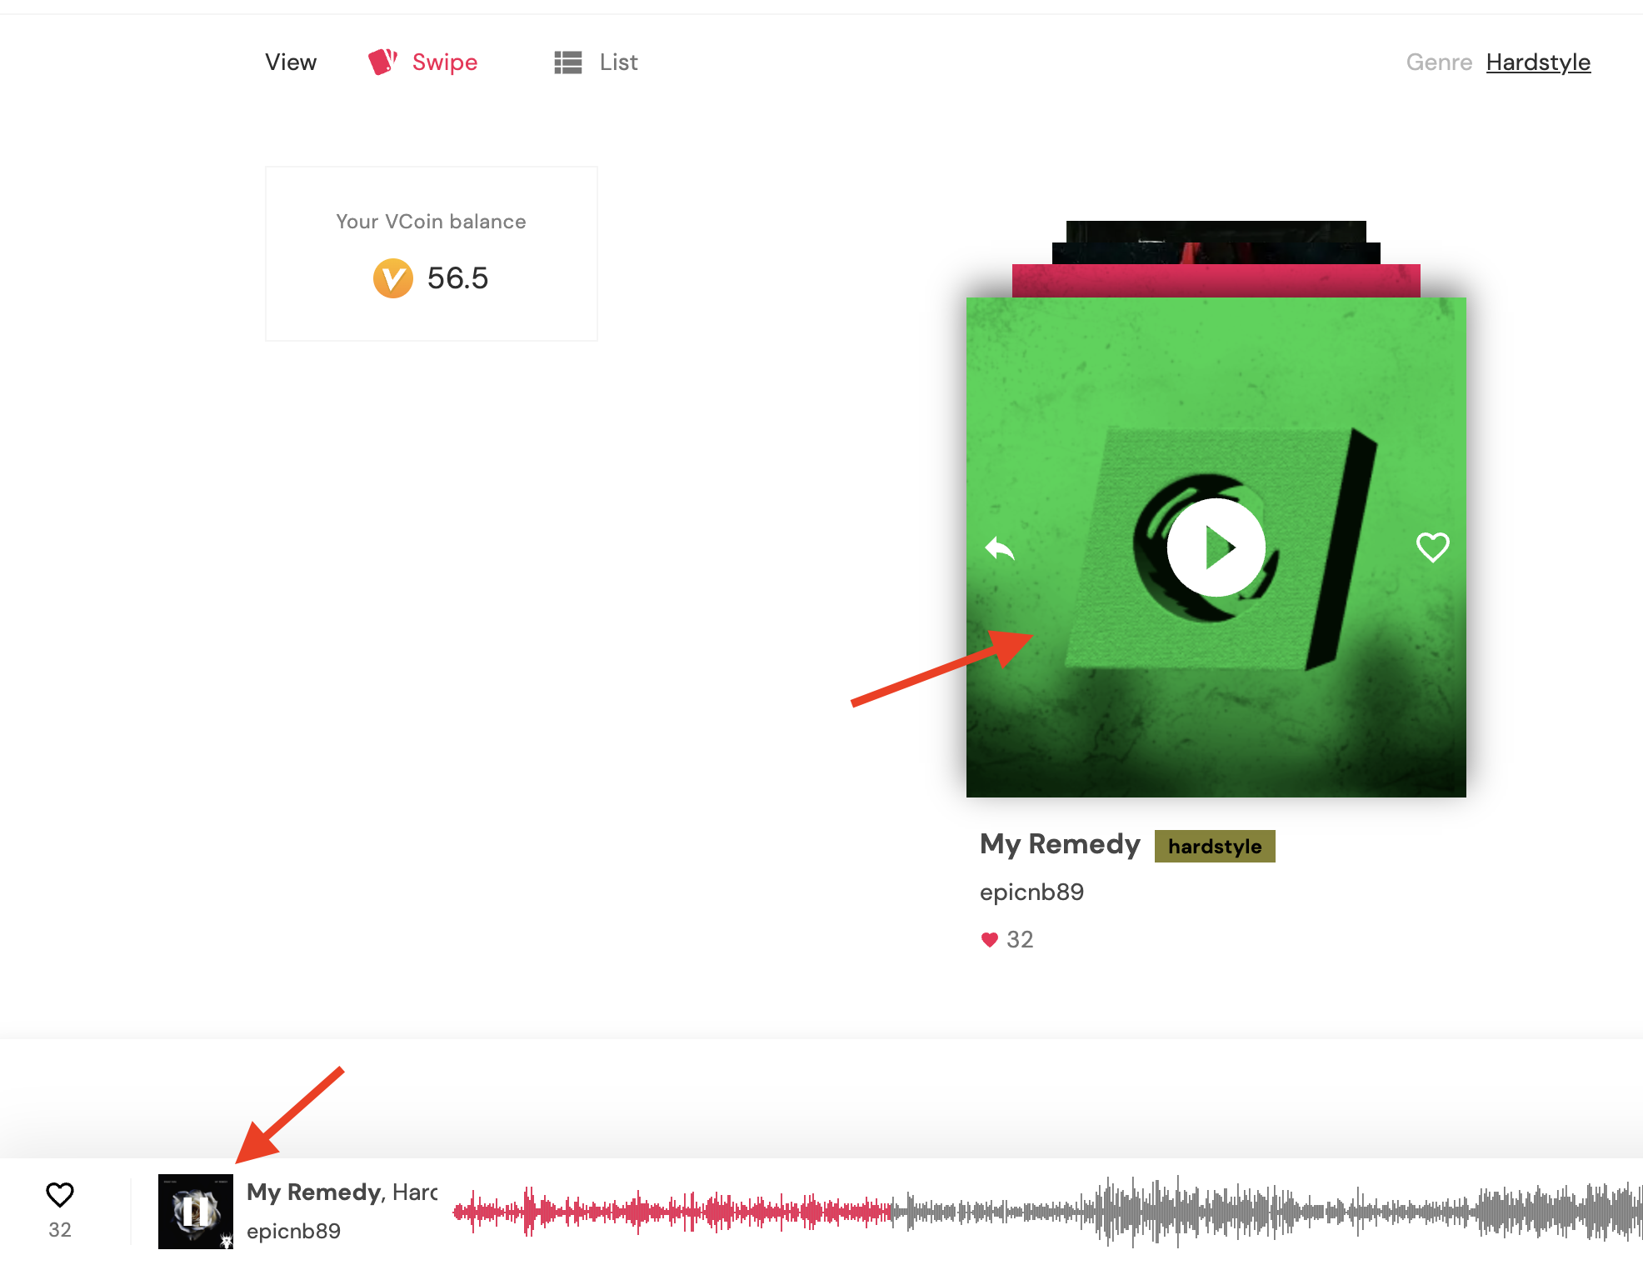

**ID** - 004

**Environment** - Google Chrome, 102.0.5005.61

**Title** - After user was added to the “User field” on the “Chat” page - it is impossible to change user or delete him

**Severity** - Medium

**Priority** - Medium

**Steps to reproduce**

* Go to <https://virpp.com/explore>
* Log in with the test data (Login - [test@dot.com](mailto:test@dot.com), Password - test123)
* Click on the “Message” button on the top right corner
* Click “View all”
* In the field “Search user” enter Test and choose it from the drop list
* Try to choose other User or delete it

**Actual result** - After user was added to the User field to write some message - it is impossible to change user or delete him

**Expected result** - it is expected that it is possible to delete or choose other user in the “Search user” field

**Atachment**

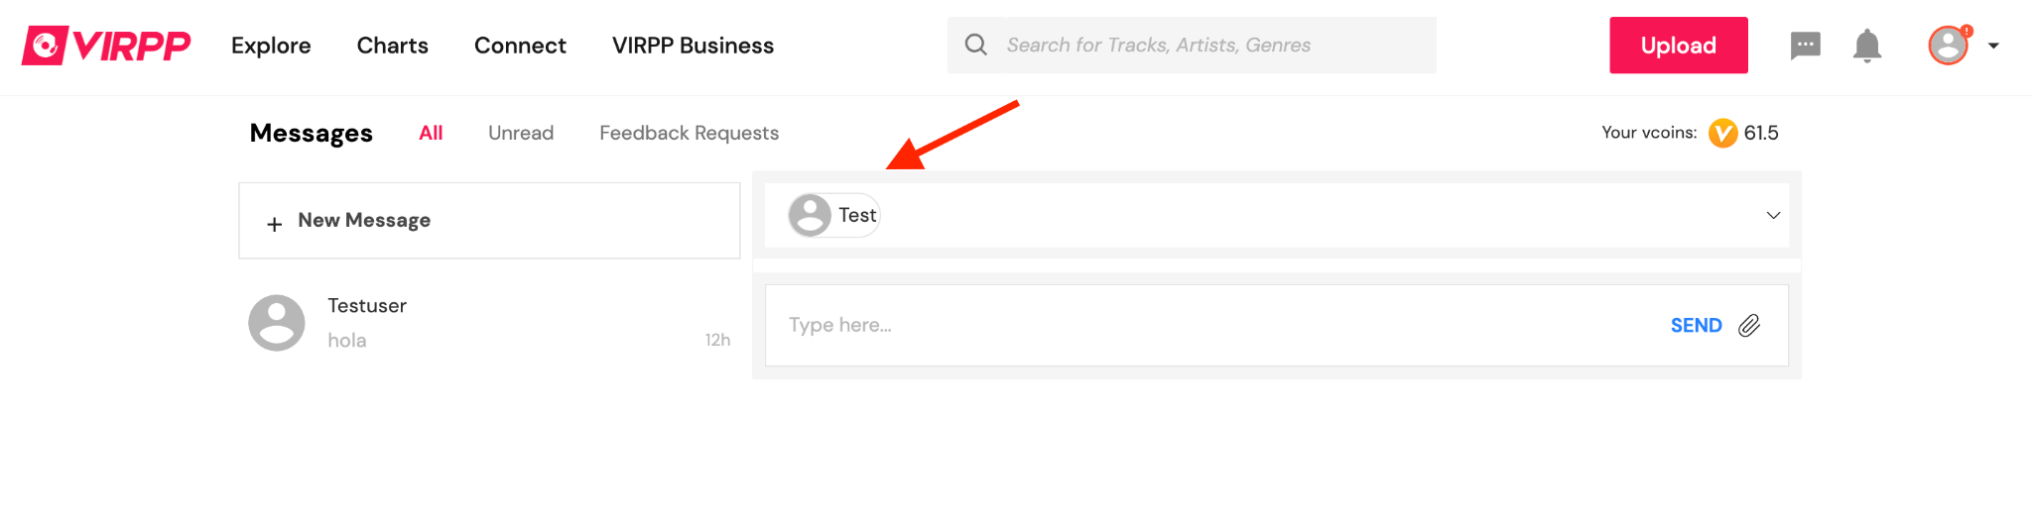

**ID** - 005

**Environment** - Google Chrome, 102.0.5005.61

**Title** - Double pop-up windows appear when adding new card

**Environment** - Google Chrome, 102.0.5005.61

**Severity** - Low

**Priority** - Low

**Steps to reproduce**

* Go to <https://virpp.com/explore>
* Log in with the test data (Login - [test@dot.com](mailto:test@dot.com), Password - test123)
* Click on the “Alarm” icon → “View all”
* Click on the “Notification settings”
* Choose “Billing info” on the left menu
* Click on the “Add new card” button
* Enter inavalid data → press “Add card”

**Actual result** - double pop-up window appear

**Expected result** - it is expected than one pop-up window has to be appeared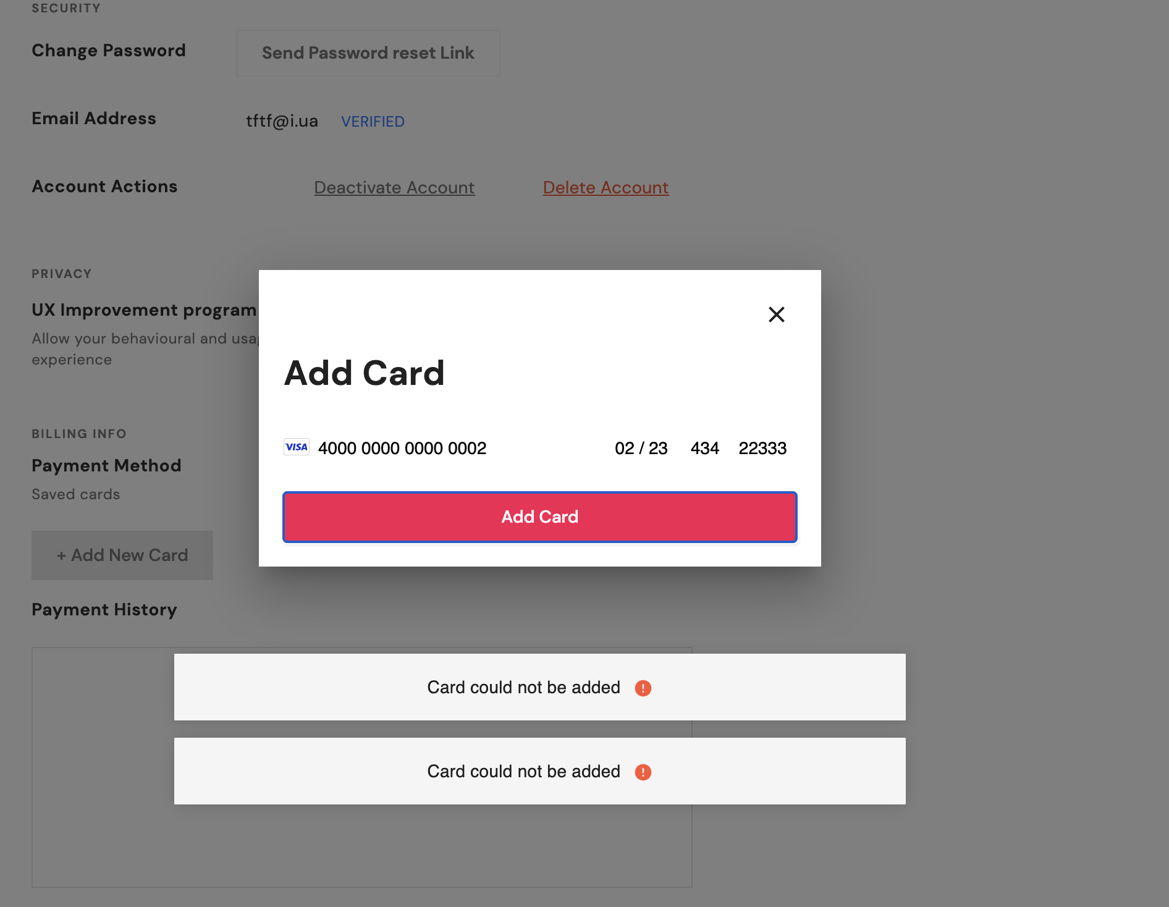

**Attachments**

**ID** - 006

**Environment** - Google Chrome, 102.0.5005.61

**Title** - There is no distance between text and frame when click on the buttons “All”, “Unread” and “Feedback Requests” on the “Chat” page

**Environment** - Google Chrome, 102.0.5005.61

**Severity** - Low

**Priority** - Low

**Steps to reproduce**

* Go to <https://virpp.com/explore>
* Log in with the test data (Login - [test@dot.com](mailto:test@dot.com), Password - test123)
* Click on the “Chat” button on the top right corner menu → “View all”
* Click on the buttons - “All”, “Unread” and “Feedback Requests”
* Pay attention on the buttons frame

**Actual result** - There is no distance between text and frame on the buttons

**Expected result** - The distance between text and frame on the button has to be

**Attachments**

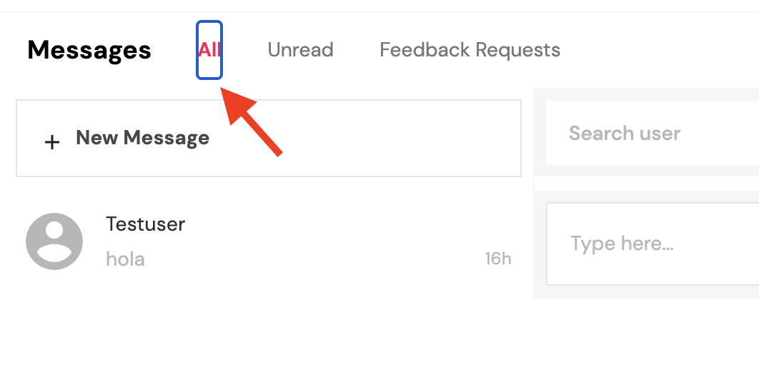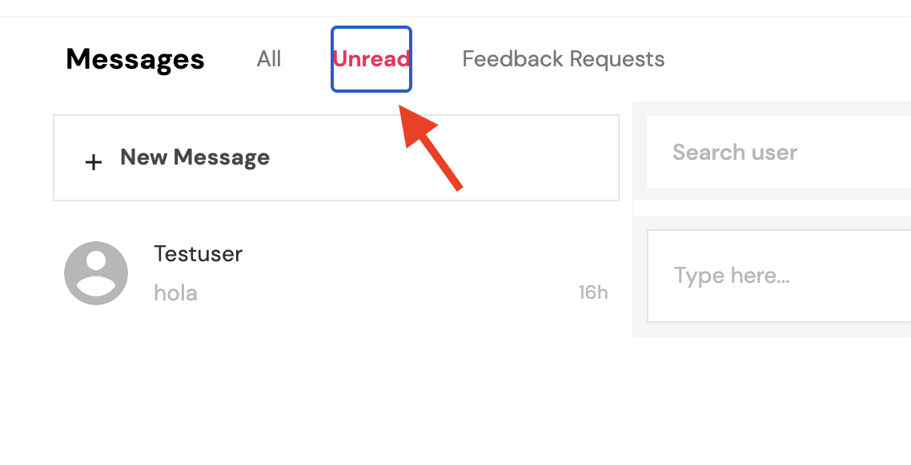

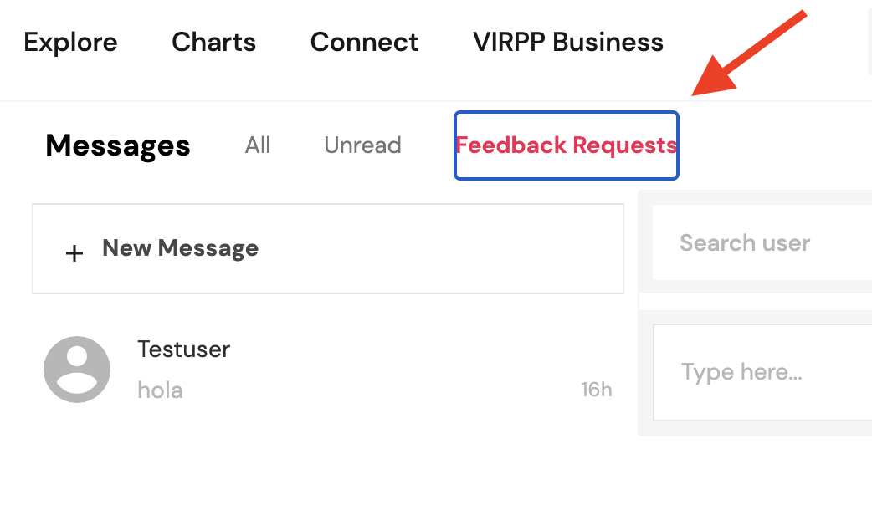

3) Do Challenge #1 from <http://testingchallenges.thetestingmap.org/index.php>

4) Send bug reports and screenshots with test results to your mentor

